**Project Report:**

**Marketing Campaign’s Performance Analysis**

**Problem Statement**

Consider the business scenario of a digital marketing agency that recently ran a digital ads campaign for one of its clients to perform marketing and positioning for their new product launch. You’re a business analyst who is working in that digital marketing agency. You’ve got the responsibility to find out how the marketing campaign is performing, by conducting the data analysis. To access how the digital campaign is going in the market, conduct a thorough Exploratory data analysis. For that, you have provided the dataset of the digital marketing campaign. Create a dashboard using the Microsoft Power BI tool, as a final output, and generate key insights by deploying it.

**Understanding the dataset**

To perform the exploratory data analysis using the Microsoft Power BI tool, we have provided a dataset of the digital ads marketing campaign which is specifically an Excel file.

Talking about the dataset, there are 20 columns and around 8000 rows are present in it which hold the data of the customers or audience of the digital marketing campaign. These are the viewers to whom the digital ads are shown.

Let’s understand the attribute (Columns) in the dataset-

1. **CustomerID** = Consists a list of customer IDs.
2. **Age** = Age of customers.
3. **Gender** = Gender of customers.
4. **Income** = Monthly income of the customer.
5. **CampaignChannel** = Tells through which campaign channel a customer gets to see ads.

[**Values:** PPC, Email, SEO, Social Media, Referral]

1. **CampaignType** = Mention which type of campaign.
2. **AdSpend** = Adspend for every individual customer.
3. **ClickThroughRate** = Show the CTR %.
4. **ConversionRate** = Describe the conversion rate for every customer.
5. **WebsiteVisits** = Total number of website visits done by a customer during the campaign.
6. **PagesPerVisit** = tell how many pages are visited by a customer.
7. **TimeOnSite** = The amount of time spent on the website by a customer.
8. **SocialShares** = Number of total social media shares done by a customer.
9. **EmailOpens** = Number of times the campaign’s emails are opened.
10. **EmailClicks** = Number of times the links provided in emails are clicked by a customer.
11. **PreviousPurchases** = Number of previous purchases done by a customer.
12. **LoyaltyPoints** = Score that will show the level of loyalty of a customer.
13. **AdvertisingPlatform** = Tells which platform is utilized for Advertising.
14. **AdvertisingTool** = Tells the tool used for Advertising.
15. **Conversion** = Tell whether the customer got converted or not, in terms of sale.

**Development Approach**

To access the performance of the digital Ads marketing campaign and communicate the key data insights along with a dashboard as a final output, I’ve performed the Exploratory Data Analysis approach by employing the **Microsoft Power BI tool**. I’ve performed all the key steps of data analysis here which are as below-

1. Exploring the data and understating the Business context.
2. Framing the Analytical goals to be implemented in the project.
3. Importing the row dataset into the Power BI.
4. Performing Data cleaning and transformations as per the requirement.
5. Performing Data modeling on the transformed data tables.
6. Introducing DAX Measures and DAX Columns as per the requirement in the analysis scope.
7. Created Data Visualization charts to implement the analytical goals.
8. Consolidated and organized all the visualization charts, buttons, and slicers into a single Dashboard.
9. By deploying the Dashboard uncovered key data insights.

**Created Dashboard (Screenshots)**

Home view-

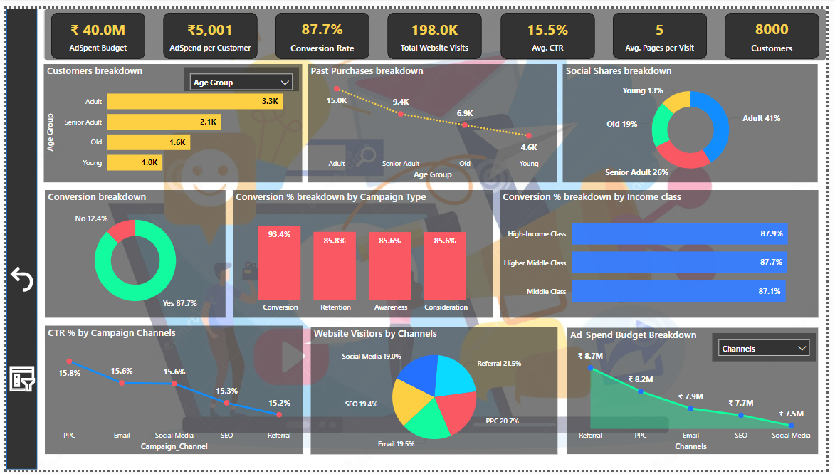

Slicer Pane view-

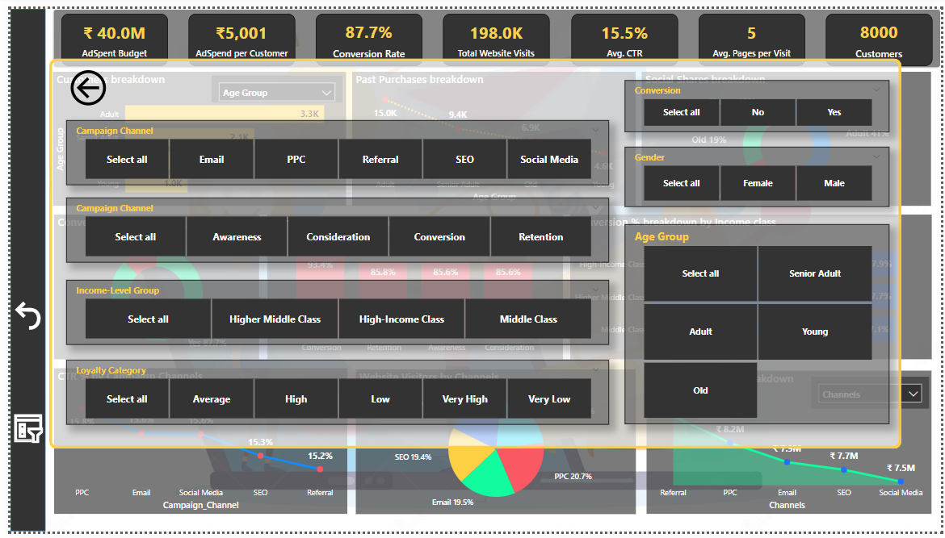

**Uncovered Data Insights**

* **List of important KPIs**
* Total Spending budget of the campaign Ads = **Rs**. **40 Million (Rs. 4 crores)**
* Adspent per customer = **Rs. 5,000 (Approx.)**
* Total Conversion rate = **Around 88%**
* Website visits during the campaign = **1 lack 98 thousand visits (2 lack visits approx).**
* Avg. CTR% for the campaign = **15.5%**
* Avg. Pages per visit = **5 pagers**
* Total customer base captured in the campaign = **8k Customers**
* **Which customer category has shown higher engagement in terms of sharing ads on their social media?**

**Ans:**

Customer Category wise highest engagement in terms of social sharing

* Age Group: **Adults -** 41% (25 to 45 aged) (164k shares)
* Gender: **Females -** 60% (241k shares)
* Loyalty Category:

**High -** 30% (121k Shares)

**Average -** 30% (120k shares)

* Income-level Category:

**High-Income Class -** 39% (155K shares)

**Higher Middle Class -** 38% (149k shares)

* **What age group of customers are the high potential customers based on the past purchase records?**

**Ans:**

Customers belonging to the ‘Adult’ age group, the age range of 25 to 45 years had the highest purchase records in the past.

* **Which gender of the customers buy more through the influence of campaign ads?**

**Ans:**

Based on the past purchase analysis we can conclude that female customers buy impulsively.

* **What is the conversion % for individual channels?**

**Ans:**

Conversion % for Channel-

* PPC = 88.3%
* Referral = 88.3%
* SEO = 87.7%
* Email = 87%
* Social media = 86.8%
* **What are the bottom two campaign channels that are generating the least website visits in the case of female customers?**

**Ans:**

Email (19%) & SEO (19.1%) are the campaign channels generating the lowest website visits by female customers.

* **What campaign channel has the highest average CTR for every age group of customers?**

**Ans:**

Channel with Highest Avg. CTR%, in every age group-

Young (Below 25) = PPC (16.2%)

Adult (25 to 45) = PPC (15.9%)

Senior Adult (45 to 60) = Social Media (16%)

Old (Above 60) = Email (17%)

**Business Recommendation**

1. The **lowest** conversion rate from the **Social Media channel** indicates underutilized digital reach that is possible on a massive scale. To cater to this inefficiency, plan to position new product launches through the influencer marketing and content creation for product awareness and hype.
2. Data shows females buy impulsively as compared to male customers, also our **around 60% customer base is female**. Hence, strategic pricing for female customers can potentially boost sales of the product launch, like special discounted prices, providing coupons, etc.
3. Insights shows that there are around **5,400 customers out of 8,000 belonging** to the **Adults** (aged 25 to 45) and the **Senior Adults** (aged 45 to 60) age groups, also these age group categories are **the top 2 in the past purchases records and showing higher social media engagement**.

To capture this significant customer segment there is needed strategic positioning of new launches with premium brand value and quality service.

1. Analysis reveals that **SEO** and **Social media** have the least budget spend, and on the other hand PPC and Referral channels consume higher ad budget spend.

To grow the sales and revenue organically it’s recommended that we have to spend more on SEO and Social media channels compared to others.

**-------------------------------------**

Developed and submitted by –

**Nikhil Losarwar.**